Puppet

# id [show user’s group]

# sudo –l [list the sudo permissions]

# df –h

# grep --color=always <word>

# grep --after-context=5 --before-context=10 <word> <file>

# shutdown -r now

# chmod +x ~/myscript.sh

# sudo chown <userID> -R <folder> [change the owner of the folder]

# sudo chgrp <userID> -R <folder> [change the group of the folder]

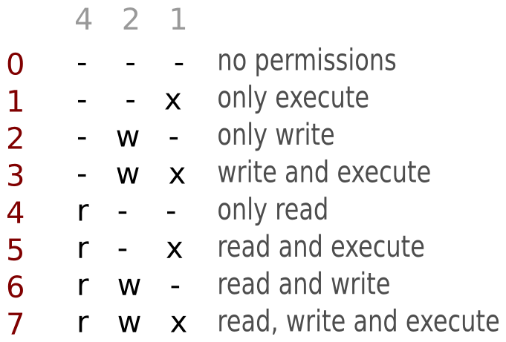# sudo chmod -R 0777 <file/folder> [To Give total permission]

# rpm -qa | grep <s/w name> [to find the available software]

# sudo mco ping -I <server_name>

# sudo su - fdx_3748658 [switch user]

# ps –ef | grep [running servers]

# sudo /etc/init.d/clo ud-elmo stop [stop elmo services]

# sudo –u <User> <command> [use command as the user]

# sudo puppet cert clean <Host name> *[remove the agent cerit in master]*

# sudo puppet cert list <Host name>*[list all the unsigned cerit in master]*

*--all [to see signed and unsigned]*

# sudo puppet cert sign <Host name> *[sign the agent cerit in master]*

# ps –fu cloudsvc  
# sudo -u cloudsvc /opt/fedex/cloud/pla*/current/bin/status_platform_service

**Paths**:

cd /var/lib/puppet/ssl/

Cat /etc/passwd [To view the user]

Cd var/fedex/cloud/ip/logs/ [ip logs]

cd /var/fedex/mkacct/includes/ [To puchtocluster]

cat ect/puppetlabs/puppet/puppet.conf

cd /var/fedex/cloud/alacarte/data/manifests/ [manifests]

cd /var/fedex/cloud/platform_service/logs [Platform_logs]

cd /var/fedex/cloud/alacarte/logs/ [alacart_logs]

cat /var/log/puppet/puppet-agent.log [Agent_logs]

cd /var/fedex/cloud/acct/logs/ [act_logs]

cd /opt/fedex/cloud/elmo/current/bin/

grep c0011026 /var/fedex/cloud/placement/logs/application*log [to see that SID and PID of the host that even de’comed]